Name: Muhammed Sayed Abdul-Aziz Mahmoud

B.N: 724

Date: 15-5-2020

Topic: Artificial Intelligence

GitHub-link: <https://github.com/MohmedSayed2001/ECE001>

GitHub-page (published website): <https://mohmedsayed2001.github.io/ECE001/>

# Application brief

Artificial Intelligence is an important topic that has so much applications, and the interest on it is increasing by the time. From virtual assistances, Google's **AI**-Powered Predictions, **AI** Autopilot to games boots, it is hard to imagine the world without these applications.

Among all of these applications what made me interested the most is the artificial intelligence gaming applications. When we play some times we assume that we are combating real people. From chess to RPG bosses all of those are empowered by artificial intelligence.

# Screen shots

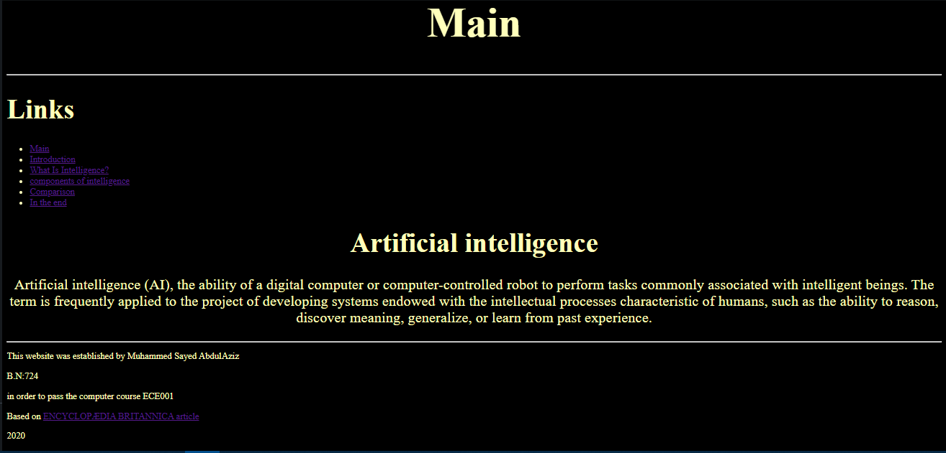

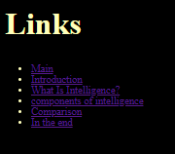

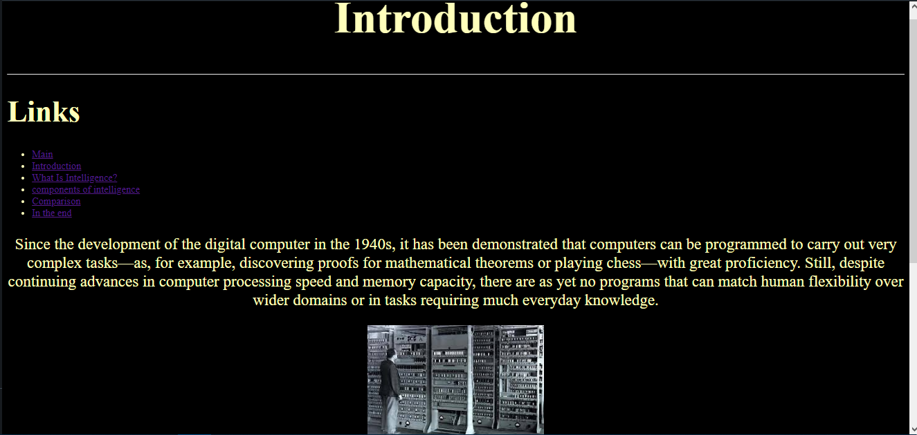 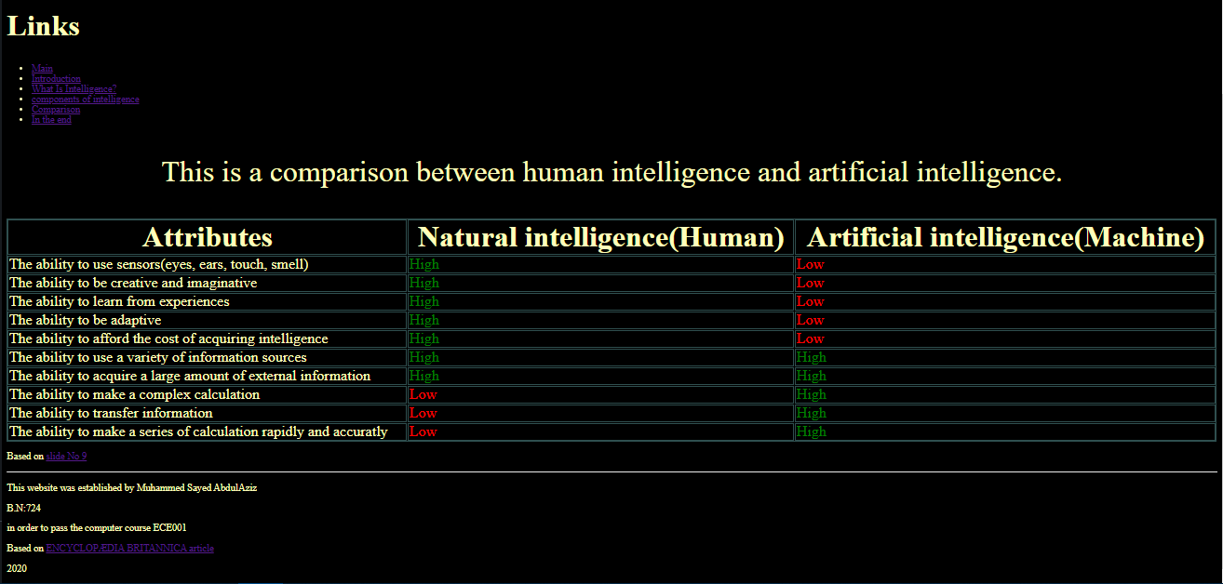 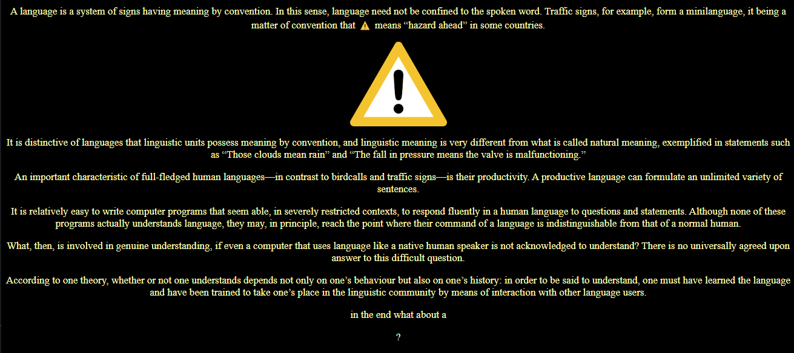 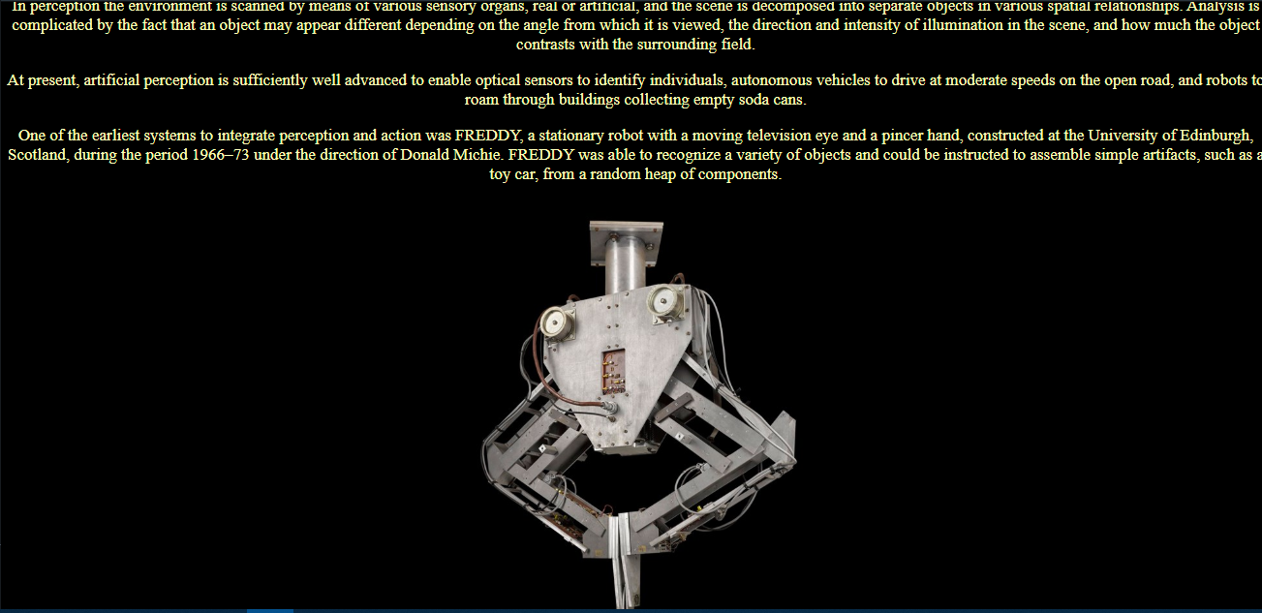

# Source code

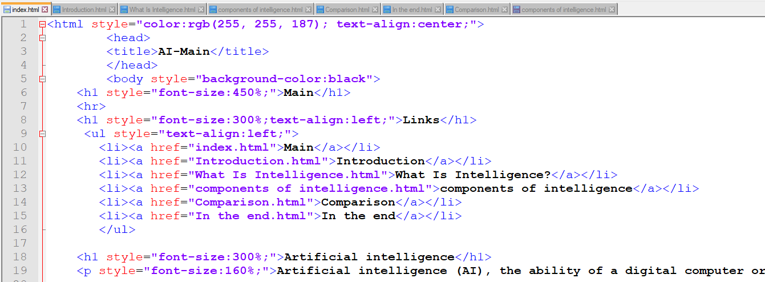

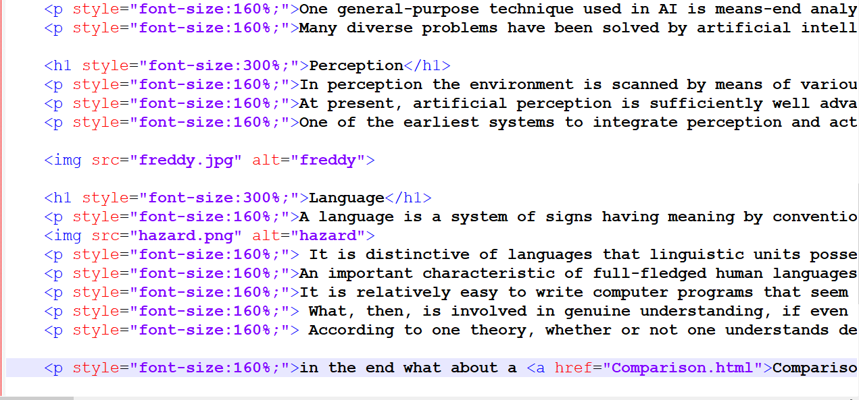

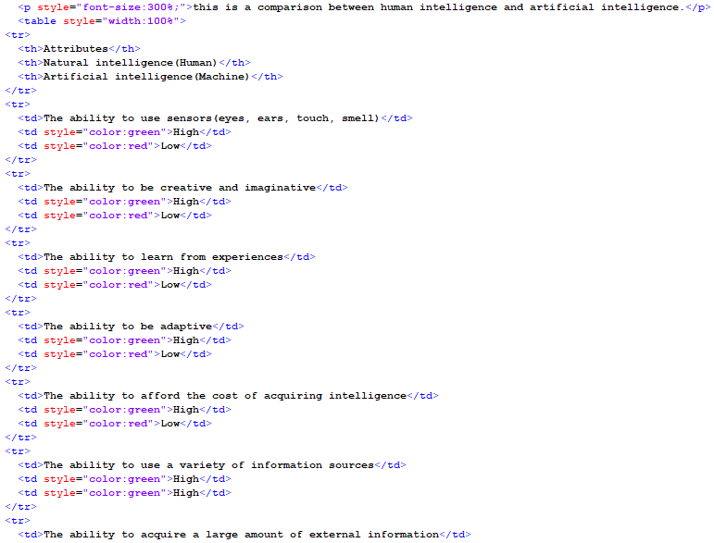

# Sources

<https://www.britannica.com/technology/artificial-intelligence>

<https://www.slideshare.net/kittysoso97/artificial-intelligence-47162326>